**Emotions – a classroom worship based on the story of Zacchaeus.**

**Teacher Notes**

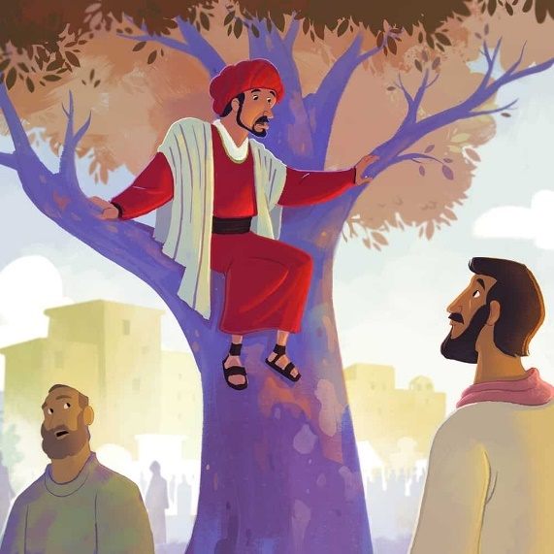

This classroom worship uses the idea of nesting dolls or

‘Russian dolls’ to encourage children to explore their emotions.

A PowerPoint is provided with all images needed but it would be

better to have a Russian doll to show the children.

**Explain to the children:** Show and explain the Russian doll –

use Slide 1 if you don’t have a real one. Have you ever seen

one of these? Do you know what it is? Sometimes we can feel like

these Russian dolls (Slide 2). Our insides just feel like they are full

of all different emotions fighting with each other.

I’m going to tell you a story about a man who Jesus met – he

was called Zacchaeus (children may well already know this story).

**The Story** (images relate to PowerPoint)



|  |  |
| --- | --- |
| Zacchaeus had lots of money but he was not a very nice man. His job was to collect and change money for the governor but he took too much. |  |
| When he took money from people he took  some money for himself. He was not kind. Nobody liked Zacchaeus. |  |
| When Jesus was coming to town, everyone went to see Him. Zacchaeus was very small. No one would let him see Jesus. |  |
| He quickly ran ahead and climbed up a tree. He waited for Jesus to go past. Now he could see Jesus. |  |
| Jesus stopped under the tree He looked up.  ‘Zacchaeus come down,’ said Jesus, ‘I am coming to your house today.’ |  |
| People said, ‘Doesn’t Jesus know that  Zacchaeus is a bad man?’ ‘Do what is good  and right, Zacchaeus,’ Jesus said. Zacchaeus  listened. |  |
| He was sorry he had taken people’s money.  He paid it all back. ‘Jesus cares about me,’ said  Zacchaeus. ‘Now I will do what is good and  right.’ |  |

**Reflection**

(Go to next slide) I’d like us to reflect back on that story and think about all of the different emotions that Zacchaeus might have felt. Can you think of any points in the story where Zacchaeus might have felt one of these emotions?

How did Zacchaeus feel at the end? What changed to make him feel this?

(Go to next slide) Imagine that you had a set of plain Russian dolls like this, how would you paint them to represent you own emotions?

I’d just like you to close your eyes for a little while and imagine the set of plain Russian dolls.

We all have many emotions swirls around inside at different times.

Think of some of the emotions that you’ve felt over the past week.

The emotion on the outside (the biggest doll) is the one that everyone sees.

When we recognise our emotions, we can control which emotion becomes the biggest doll.

Which emotion do you want that to be?

**Closing prayer**

I am going to finish with a prayer now and if you would like to make it your own prayer, you can say Amen at the end.

Dear God,

Sometimes our emotions are jumbled and confused,

Sometimes they come racing to the surface

and we lose control of them.

Help us to remember that you care for us,

Just as Jesus cared for Zacchaeus.

Help us to control our emotions so that

Other people see the best part of us,

Just as you do.

Amen

