A Harvest for the World – a classroom reflection based on the Parable of the Sower.

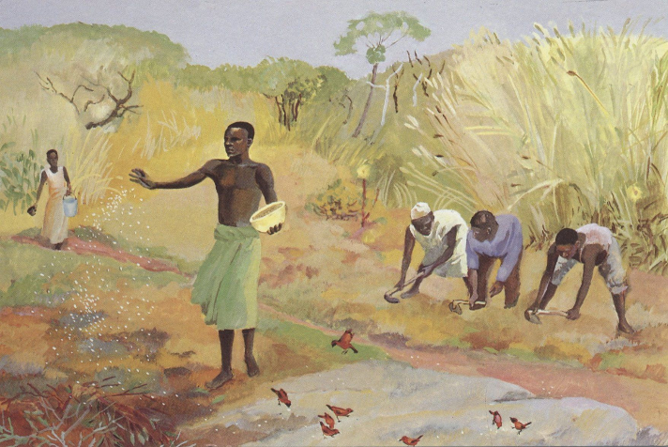
Teacher Notes

This reflection uses the Isley Brothers song
‘A Harvest for the World’. Children will probably prefer
the more modern version by The Christians, which is
available on any streaming platform.

Explain to the children: At this time of the year we
often think about Harvest. When Jesus was trying to
explain to people about the Kingdom of God, he often
used images from farming.

I’m going to tell you a story that Jesus told his followers, this image might help you to imagine it (show first PowerPoint slide).

The Story
One time, Jesus told his followers this story: A farmer went out to sow seed. While he was scattering the seed, some of it fell by the road. The birds came and ate all that seed. Other seed fell on rocky ground, where there was not enough dirt. It grew quickly there because the soil was not deep. But then the sun rose and the plants were burned. They died because they did not have deep roots. Some other seed fell among thorny weeds. The weeds grew and stopped the good plants from growing. So they did not make grain. But some of the seed fell on good ground. There it began to grow, and it made more and more grain.
The disciples didn’t really understand the story so Jesus told them (show second PowerPoint slide): The farmer is like someone who plants God’s teaching in people. Sometimes the teaching falls on the path. That is like some people who hear the teaching of God. As soon as they hear it, selfishness gets the better of them and they ignore it. Other people are like the seed planted on rocky ground. They hear the teaching, and they quickly and gladly accept it. But they don’t allow it to go deep into their lives. As soon as it gets difficult, they give up. Others are like the seed planted among the thorny weeds. They hear the teaching, but their lives become full of all the things they want to get for themselves. This keeps the teaching from growing, and it does not produce a crop in their lives. And others are like the seed planted on the good ground. They hear the teaching and accept it in their hearts. Then they pass it on and the world becomes a better place for everyone.

Reflection

I’m going to play you a song now and I will put the lyrics up on the screen. I’d like you to think about lyrics and how they might link to the story that we just heard. I hope you like the song – it’s an old song but it’s very catchy!

After listening to the song, ask the children what the song is asking. Look at fourth PowerPoint slide. Relate this to the idea that there will only be a harvest for the whole world when everyone lives out God’s values.

Return to the second image, tell the children that we are going to have a short time of reflection. They can either look at the image or close their eyes.

Jesus says that there are four kinds of people:
Those who ignore God’s values because their hearts are full of selfishness.
Those who are enthusiastic about God’s values but easily forget them.
Those who accept God’s values but let their own concerns get in the way.
Those who carry God’s values in their hearts and make the world a better place for everyone.

Which do you want to be?

Closing prayer

I am going to finish with a prayer now and if you would like to make it your own prayer, you can say Amen at the end.

Dear God,
You have taught us that every one of us is precious to you
But that we have a responsibility to care for one another other.
Help us to carry your values in our hearts
So that there can be a harvest for the world
And all people may share in its goodness.
Amen

