Triathlon – a classroom worship based on the story of the Santander Triathlon.
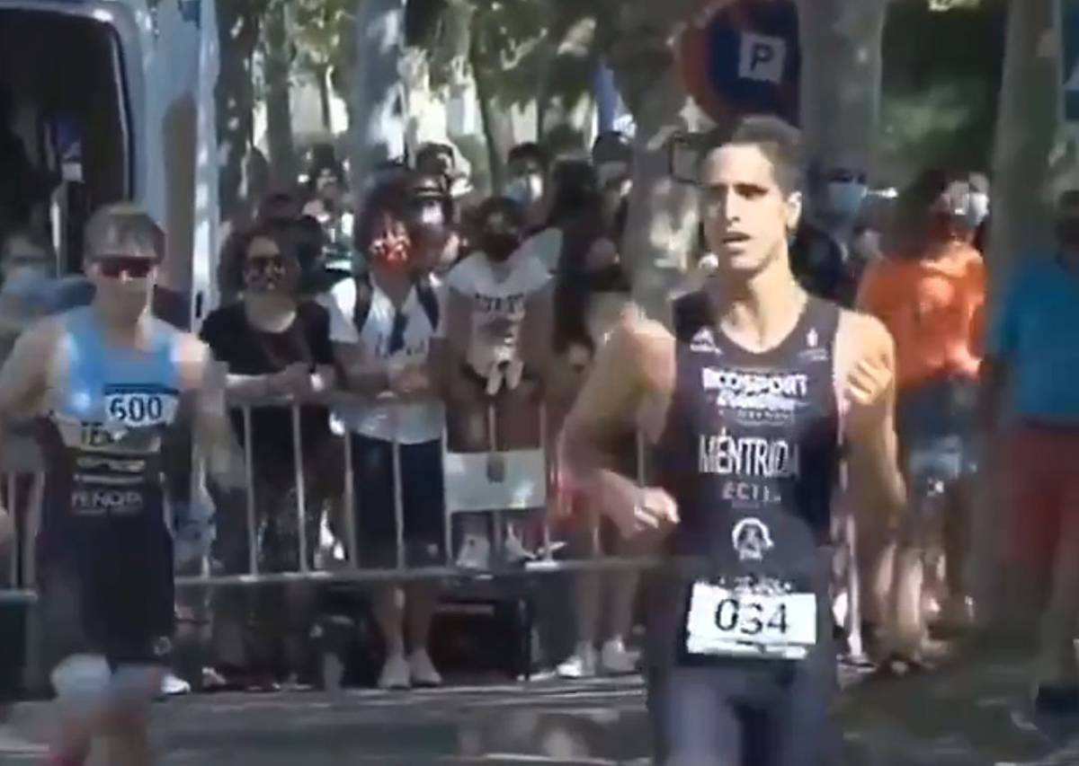

Teacher Notes

This classroom worship is based on an event at the recent Santander Triathlon, when the British athlete James Teagle took a wrong turning at the end of the race and his Spanish rival Diego Méntrida stopped to let him take third place. The story went viral and Méntrida was later awarded an honorary bronze medal (his first ever!) and the same prize money of €300 (£275).
You can read the story here. (The page also contains a link to a similar story from the London Marathon, where a runner sacrificed his place to help another athlete make it to the finishing line)

Opening activity

Ask the children to imagine it’s sports day and they’re running really well. (PowerPoint slide 1) Just as they get close to the end of the race, they trip up and another child overtakes them and finishes the race in first place. How would they feel? What might the other child feel? What would be a better ending to the race? How would they react if they saw somebody else trip up?

Story

Show this Spanish clip of the Santander Triathlon, where Méntrida stops and waits for Teagle to catch up with him. (PowerPoint slide 2)
Ask the children what they think is happening. James Teagle took a wrong turning and ran into a barrier, rather than towards the finishing line. When Diego Méntrida realised what had happened, he stopped to let the British athlete catch up. They shook hands and crossed the line together.
What do the class think of his actions? Why would someone give up a medal they had worked so hard for? Méntrida said that Teagle had been ahead of him all through the race and deserved to win. His parents and his athletics club had always taught him to play fairly, but he never expected it to be so costly! Sports fans around the world have praised his sportsmanship and Teagle tweeted that this showed the real values of sport in a single gesture.
What if other athletes and sports players behaved like this?

Reflection

Méntrida had trained hard for the race and was metres away from winning a bronze medal. How do you think he felt when he stood aside and let James Teagle overtake him? In the end, he became world famous for showing good sportsmanship and was awarded an honorary bronze medal and the €300 prize money.
Show PowerPoint slide 3. Sometimes it pays to do the right thing! Jesus told us that God’s values are different from the world’s values and that one day there would be a lot of surprises for his followers. ‘The last shall be first and the first shall be last.’ (Matthew 20:16)

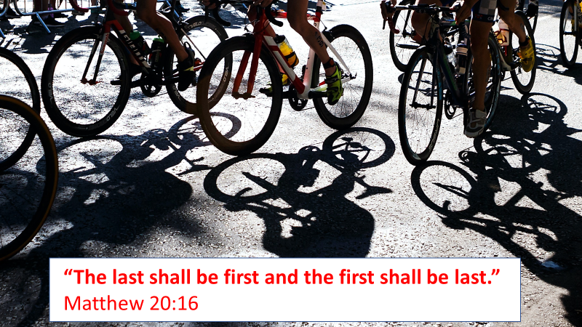
Show PowerPoint slide 4 and read these words from the bible slowly.

Put other people first ... don’t push your way to the front; don’t sweet-talk your way to the top. Put yourself aside, and help others get ahead.
Don’t be obsessed with getting your own advantage. Forget yourselves long enough to lend a helping hand.
Think of yourselves the way Jesus thought of himself. He had equal status with God but when the time came, he set that aside and took on the status of a slave, he became human! Having become human, he stayed human. It was an incredibly humbling process. He didn’t claim special privileges. Instead, he lived a selfless, obedient life and then died a selfless, obedient death.
Because of that obedience, God lifted him high and honoured him far beyond anyone or anything, ever.
Do everything readily and cheerfully—no arguing, no squabbling! Be a breath of fresh air in this squalid and polluted society. Show others the right way to live. Be the light shining in the darkness!
(Adapted from Philippians 2, The Message version)
What if everyone behaved like this? When might it be difficult?
Challenge the children to remember the example of Diego Méntrida next time they have the opportunity to put someone else first.

Closing prayer

I am going to finish with a prayer now and if you would like to make it your own prayer, you can say Amen at the end.

Dear God,
Thank you for Diego Méntrida.
Thank you that he did the right thing and let the other athlete win.
You told us to put other people first.
Help us to remember that today,
and not push our way to the front.
Amen

Do Unto Others
Billy Bragg
In the Bible, we are told
God gave Moses in the days of old
Ten great Commandments
For his people to hold true
But the greatest commandment of all
Is in the book of Luke, as I recall
Do unto others as you would have them do to you
Do unto others as you would have them do to you
Now if, baby, you don't believe
In the story of Adam and Eve
Who called upon science
To prove it's all untrue
But in the cold light of the day
Peaceable words still point the way
Do unto others as you would have them do to you
Do unto others as you would have them do to you
So just lift up your eyes
Don't pass by on the other side
Don't be bound by what you think others may do
Well, just a little bit of faith
And that's all it really takes
Do unto…
So just lift up your eyes
Don't pass by on the other side
Don't be bound by what you think others may do
Well, just a little bit of faith
And that's all it really takes
Do unto others as you would have them do to you
Now the way the world is run
Too many people looking after number one
Don't seem to notice
The damage that they do
Though it's not widely understood
There is, there is a greater good
Do unto others as you would have them do to you
Do unto others as you would have them do to you

