‘Gifts’ – a classroom worship based on the story of the wise men.

Teacher Notes

Epiphany, or the twelfth day of Christmas, celebrates the visit of the wise men on 6th January and is an important Christian festival in many parts of the world. In Spain, traditionally, it is los reyes magos, or the wise kings, who bring children their Christmas presents, although this is beginning to change and many children now receive their presents on Christmas Day. In France, families eat a special cake, the gallette des rois, and whoever finds the fêve (a hidden bean or charm) gets to wear a crown and be king or queen for the day.
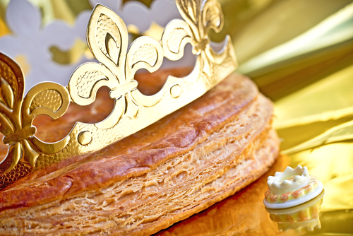
In this reflection, we will focus on the Wise Men’s gifts, but the story is also important because it shows people of different backgrounds and nationalities coming to worship Jesus.

Introduction

PowerPoint 1. Ask the children what is the most surprising gift that they’ve ever received. You might have your own story to share about an unusual gift - perhaps you could bring it in and show them? Or you may like to show them a parcel and ask them to guess what’s inside it. Tell them that today we will be thinking about some surprising gifts.

Reflection

Show a picture of one of the wise men (PowerPoint 2) or a figure from a nativity set and ask the children if they know who it is. What can they tell you about him? They will probably tell you that there were three kings, so it’s worth establishing that the Bible doesn’t tell us how many there were and never says that they were kings. All we know is that they were astrologers or religious leaders who came from the East and brought three gifts. The Bible doesn’t mention camels or tell us their names. (According to tradition, they were Caspar, Melchior and Balthasar.) Having said all that, you might like to play a version of We Three Kings; the links on slide 2 take you to a modern version or a traditional choir from Kings College, Cambridge. You can decide which will work best with your class.
Do the children know what the wise men gave Jesus? (PowerPoint 3) What is surprising about their gifts? What would you normally give a new baby? Their gifts were specially chosen and had a meaning. Do the children know what they represent? Gold was the sign of a king, Incense was used in worship and Myrrh was used to anoint dead bodies. Why would they have given Jesus these presents?
Christians sometimes talk about what they would give to Jesus. Of course, he doesn’t need actual presents, so they talk in terms of giving their time or energy or using their resources to help other people. Jesus once said that anything his followers do for other people is as if they were doing it for him. (Matthew 25:40) (PowerPoint 4)
Christina Rosetti was a nineteenth century artist and poet and she wrote about giving Jesus her heart. (PowerPoint 5) She can’t have meant it literally, so what do the children think this means? Could it mean giving practical help to people around us? Could they do something practical to help a relative or a neighbour? Do they know anyone who is lonely perhaps, or isolated by COVID-19? Could they make a card? Bake a cake? Is there someone in school they could help?
Christina Rosetti’s words are the last verse of the carol ‘In The Bleak Midwinter.’ You could play this while the children take time to reflect and decide how they want to respond. (The PPt has links to the Kings College Cambridge choir or to a modern version of her words.) You could ask them to write something positive they plan to do, or a prayer, on a heart template. Or they might have practical ideas such as making cards for a local old people’s home or something else in response to a local need.
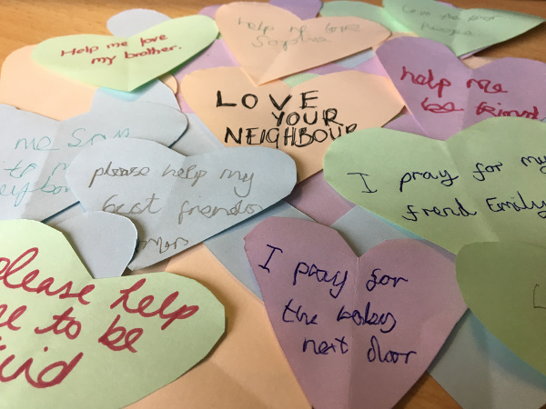
Closing prayer

Read this prayer (PowerPoint 6) or ask one of the children to read it. Invite the class to say ‘Amen’ at the end if they agree. Alternatively, you could ask some of the children to say their own prayers in response to the ideas you have talked about.

Father God,
Thank you for the story of the wise men who came to visit Jesus.
Thank you that they made the effort to go on a long journey and for their gifts.
Help us to make the effort to show love to other people.
Help us to be generous with our time and energy.
Amen

