‘Do Unto Others’ – a classroom worship based on the Golden Rule.

Teacher Notes

This classroom worship is based the golden rule, do unto others as you would have them do unto you. Jesus taught this in the Sermon on the Mount, but the idea is almost universal.
The ideas in this reflection are drawn from the Anti-Racist RE resources, written in response to the Black Lives Matter campaign, which contains some really useful materials to use in upper KS2, but this is a much more general reflection about treating others well.

Introduction

When have you heard someone say, ‘How would you like it if they did that to you?
This is a form of the ‘golden rule.’(PowerPoint slide 1) Jesus taught his followers to ‘do to others what you would have them do to you.’ (Matthew 7:12).
Most religions and cultures round the world have a version of this; why do you think it is so common?
Sometimes the negative form of this (‘Don’t do to others what you don’t want done to you’) is called the silver rule; why do you think that is? Which version of the rule do you think is better? Why?

Song

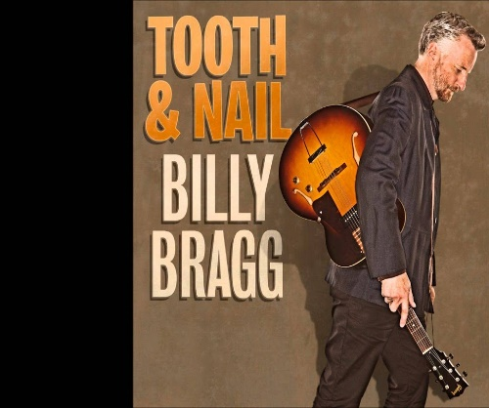
Play Billy Bragg’s song ‘Do Unto Others’ (PowerPoint slide 2)
(The lyrics are printed at the end of this resource)
There is a live recording here if you prefer.
What do you think he means by ‘Too many people looking after number one’? (PowerPoint slide 3)

What would change if everyone followed the golden rule in your friendship group? In your class? In your town? In the whole world?

Which of our school values fits the golden rule best?

Reflection

Show PowerPoint slides 4 – 12. These are taken from winning entries in the Spirited Arts Competition on the theme of the golden rule. Ask the children to think about which one is best at expressing the idea of treating others as you would like to be treated. (Not necessarily the most artistic!) How would they express the theme?
Closing prayer

I am going to finish with a prayer now and if you would like to make it your own prayer, you can say Amen at the end.

Dear God,
Help us to remember the golden rule.
Help us to be kind and thoughtful and to treat other people the way that we would like to be treated.
Amen

Or ask for volunteers in the class to say their own prayer, based on the ideas you have discussed.

Do Unto Others
Billy Bragg
In the Bible, we are told
God gave Moses in the days of old
Ten great Commandments
For his people to hold true
But the greatest commandment of all
Is in the book of Luke, as I recall
Do unto others as you would have them do to you
Do unto others as you would have them do to you
Now if, baby, you don't believe
In the story of Adam and Eve
Who called upon science
To prove it's all untrue
But in the cold light of the day
Peaceable words still point the way
Do unto others as you would have them do to you
Do unto others as you would have them do to you
So just lift up your eyes
Don't pass by on the other side
Don't be bound by what you think others may do
Well, just a little bit of faith
And that's all it really takes
Do unto others as you would have them do to you
Now the way the world is run
Too many people looking after number one
Don't seem to notice
The damage that they do
Though it's not widely understood
There is, there is a greater good
Do unto others as you would have them do to you
Do unto others as you would have them do to you.

