Clouds – a classroom reflection.

Teacher Notes

The best kind of clouds for this activity are the white, fluffy cumulus clouds (from the Latin word for ‘heap,’ your class might like to investigate the names of other cloud types.) Lie on your backs outside and spend a few minutes looking up at the clouds (or stand and stare if this is more practical, or even look out of the window, but this won’t have the same wow factor!)
Remind the children not to look directly at the sun.
Alternatively, Cbeebies have a cloud spotting video you could watch (First PowerPoint slide)

Class discussion:
What words can they think of to describe the clouds? What shapes can they see? Animals? Faces? Other objects? Encourage them to be as imaginative as possible, you might need to start the ball rolling with a few suggestions of your own!
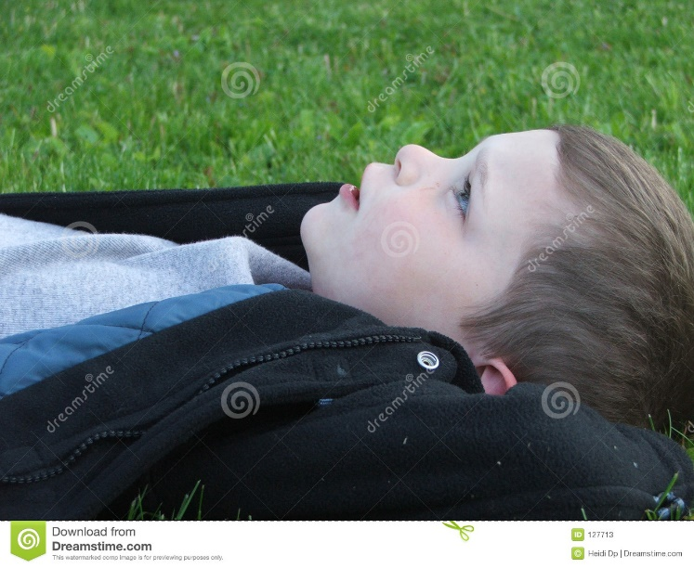
How does cloud watching make you feel?
Peaceful? Small? Dreamy?
(Second PowerPoint slide)
Spend some time discussing how clouds can remind us that the world is bigger than our fears and worries. Some people say that cloud watching helps them get a sense of perspective on their lives and makes them feel more peaceful. What do the children think?

Bible Reading

Ask a child to read these words from the bible. (Third PowerPoint slide)
‘Sing to the Lord with thanksgiving,
make music to our God on the harp.
He covers the sky with clouds,
he supplies the earth with rain,
and makes grass grow on the hills.’ (Psalm 147: 7-8.)
Christians believe that God looks after the world and that they can trust him to take care of them too. In many cultures, clouds are seen as a sign of blessing. For example, in Iran you can wish someone well by hoping that their sky is full of clouds. Why might this be the case?

Closing Prayer
Ask one of the class to read this prayer. (Fourth PowerPoint slide)
“Dear God, watching the clouds makes us feel peaceful and reminds us that you are in control. Help us to trust you and feel your peace as we live our lives today. Amen.”
Or alternatively, encourage the children to make up their own prayers, developing the ideas you talked about in the discussion.
They could write these on cloud outlines. There’s an example of a cloud template here.

Alternative activity
You might like to develop the idea of dreaming big. Cumulus clouds grow bigger and bigger as more and more water droplets are gathered together. (Think of the word ‘accumulate’)
What are your dreams for the future? What do you want to achieve in life? Where do you want to go? What sort of person do you want to be?
Sometimes we feel small and unimportant and it’s hard to dream big, but big dreams can change the world! Ask them to draw or write their dreams onto a cloud shape and encourage them to keep dreaming!
Clouds are made up of millions of miniscule water droplets. Our futures are made up of the millions of tiny steps that we take every day. Having big dreams for the future can help us make good choices today.

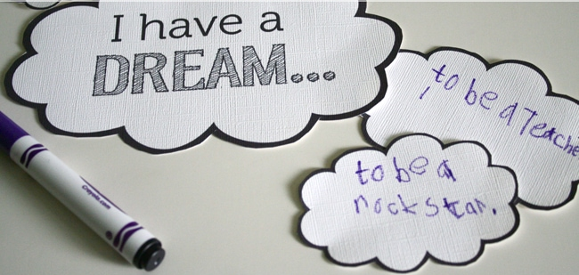

Dear God, thank you that you know all our hopes and dreams for the future. Please guide us to make good decisions day by day and help us to achieve great things!
Amen.
You can find a version of this activity, called Dream Clouds, on the Prayer Spaces in Schools website. It is free to register and there is a great selection of tried and tested classroom prayer activities.

Reflection

