Suggested texts on the subject of Hope

Biblical hope isn’t a “wish and a prayer” outlook, where we want something with all our might even though we aren’t sure if it will really happen.
The word “hope” in Greek (the language of the New Testament) is “elpis”, which means “expectation, trust, confidence”. When that word is used in the Bible, it refers to actively waiting for God’s fulfillment of what He promised.

Bible Verses About Hope
Matthew 12:17-21 (NLT)
This fulfilled the prophecy of Isaiah concerning him:
“Look at my Servant, whom I have chosen. He is my Beloved, who pleases me. I will put my Spirit upon him, and he will proclaim justice to the nations.
He will not fight or shout or raise his voice in public. He will not crush the weakest reed or put out a flickering candle. Finally he will cause justice to be victorious. And his name will be the hope of all the world.”

Romans 15:13 (NLT)
I pray that God, the source of hope, will fill you completely with joy and peace because you trust in him. Then you will overflow with confident hope through the power of the Holy Spirit.

Hebrews 6:19 (NIV)
We have this hope as an anchor for the soul, firm and secure.

Romans 5:5 (NLT)
And this hope will not lead to disappointment. For we know how dearly God loves us, because he has given us the Holy Spirit to fill our hearts with his love.

Bible stories about Hope
- Jacob’s Dream Genesis 28
- Story of Samuel 1
- Samuel 1-3
- The promised King Isaiah 9, Micah 5
- Gabriel Visits Mary Luke 1
- Palm Sunday Matthew 21
- The Empty Tomb John 20
- Jesus Ascends into Heaven Acts 1

Secular stories about Hope

- Wonder Goal (Michael Foreman)
- The Valley of Secrets (Charmain)
- Goodnight Mr Tom (Hussey)
- Not the End of the World (M. Magorian)
- Dear Max (G McCaughrean)
- The Owl who was Afraid of the Dark (Jill Tomlinson)
- For Every Child (UNICEF)
- Jasper’s Beanstalk (N. Butterworth)
- The Tiny Seed ( Eric Carle)

This book looks at Hope through extracts from stories, artwork and poetry.

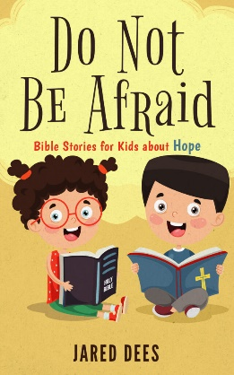
The stories contained in this book offer God’s hope to young readers.

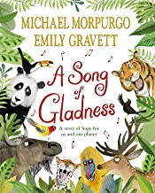
A story of for us and our planet hope

