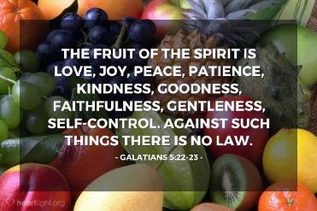



**Brick wall prayers**

**Teacher Guidance**

**Context:** This prayer activity involves preparing public statements about what is important to pray about.

**You will need:** paper cuboid templates appropriate for a brick shape, pencils/pens/paints, scissors, glue

Initiate a time of quiet reflection for the children to think about what values are important to them. Explain that this can also be prayer; it is not just when we are reciting prepared words out loud. Ask the children to write the object of their prayer for a fairer world on their ‘brick’ - it could be a slogan, a word or a picture. The bricks can then be attached together to create a prayer wall.

An alternative could be a version with small wooden bricks (similar to Jenga blocks) which could be written on and glued together to create a more permanent prayer wall of justice or other value themes.

Another alternative could be 2-D bricks arranged and glued together on a piece of lining paper to create the wall effect.

Once the wall has been completed, it can be a location where the children are encourage to stand and read the words either quietly or as a discussion with others. This can also be prayer!

**Further reflection:** It might seem a small gesture to display a word or sentence on a wall, but can it have a much greater impact than you might think? Research shows that visual stimuli in prominent places can have a huge influence on people’s thinking.

* What do you see around you that makes you think (in particular, that might make you think differently about something)?

Our actions can be a bit like a moving values wall. We can display many positive values by the way we behave towards others and interact with the world around us.

* What positive values would you like others to see in you?

Christians believe that the Holy Spirit’s presence with them helps them to act with many positive values, summarised here in the list of the fruits of the spirit.

We can ask God to help us with these if we find some of them difficult, and most of us do! We are often naturally better at some than others.

Which of these do you think come more naturally to you and for which do you think you need to get better?