Advent Paperchain Prayers - Week 4

Teacher Notes

You will need some pre-cut strips of coloured paper - an A4 sheet makes six strips comfortably - or you could use triangles to make bunting, or hang up luggage labels with fairy lights as in the picture below.

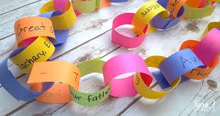
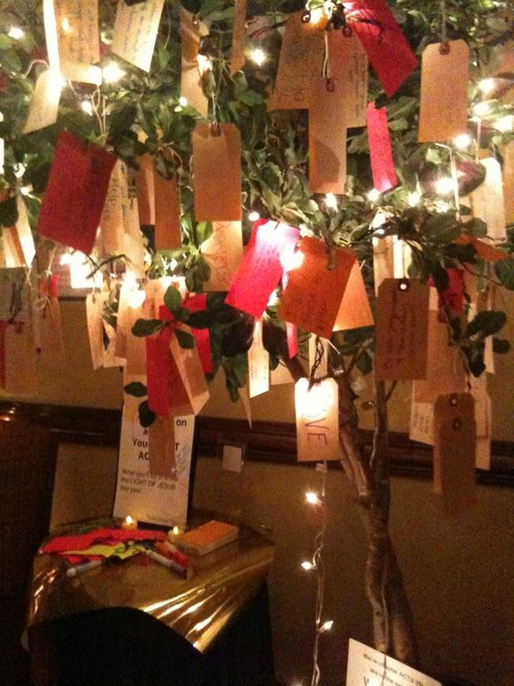

With the children:

Remind the children that this week we are thinking about joy, because Mary was joyful when God chose her to be Jesus’ mother. Ask the children what makes them joyful. You might like to show them this video from Downton Primary School near Salisbury, to get them started.
Can you make a class acrostic together, spelling out the word ‘joyful’?
E.g.
Jumping on the trampoline
Outings to the park
Yummy chocolate cake
Fried egg sandwiches
Unwrapping presents
Laughing with my friends!

(‘Happiness’ or ‘Celebrate’ might have easier letters!)

Ask everyone to write (or draw) something that gives them joy on a strip of paper and staple them together to make a class paperchain (or bunting etc)

It can have quite an impact if you ask the children to read out their words or sentences in a random order, as and when they want to. You may have a couple of false starts, but encourage them to watch each other’s body language so they don’t all speak at once.

Closing prayer

If you have made and advent wreath, you may like to finish by lighting the candles and use the candle lighting prayer (or you could copy the image below into a PowerPoint slide to display).

As we watch and wait for the coming of Jesus,
We remember that he came to bring:
Hope where there is despair,
Peace where there is violence,
Love where there is hatred,
Joy where there is sorrow,
And light where there is darkness.
Amen

Or you could use this week’s prayer about Mary being joyful because God had specially chosen her.

Dear God,
Thank you that we can find joy and laughter in ordinary, everyday things.
Thank you that Mary trusted you and was glad that you had chosen her.
We pray for people who don’t feel joyful at the moment and ask that you will help them find smiles in unexpected places.
Amen.

