Advent Guided Reflection - Week 4
The Annunciation.

Teacher Notes

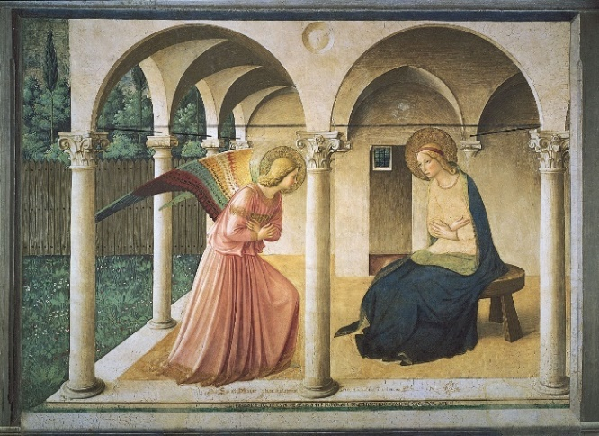
A PowerPoint of the image opposite accompanies this
reflection, which may be projected for the children to look at.
The painting is called ‘The Virgin of the Annunciation’ by Fra Angelico and is one of a series of frescoes at the San Marco Monastery in Florence. It was designed as a tool for the monks to meditate on and reflect about the story. This was one of the first paintings to show Mary in a more natural, outdoor setting, rather than inside on a throne. It marks the beginning of the Renaissance period, when artists started to understand light and perspective.

Explain to the children:

In this fourth week of Advent, we have been thinking about Mary and how the Angel Gabriel told her she would have a baby, who would be called Jesus and would be the Son of God. Today we are going to think more about the difference this would make to Mary’s life and how she responded to the news.
The picture on our board is an artist’s impression of how he imagined the scene in the story.

What do you notice about the way Mary is sitting? (Does she look proud and important, or simple and humble?) What do you notice about the angel’s body language? (Is this a big public announcement, or a quiet, private conversation?)

Look at the picture, while I read the story about what happened when the Angel Gabriel visited Mary.

An Angel Appears to Mary
Mary was a young girl living in the village of Nazareth. She was engaged to marry Joseph. One day, the Angel Gabriel came to her, saying, ‘Peace be with you, Mary. God has chosen you for something wonderful.’
Mary couldn’t believe her ears. ‘Me? God chose me?’ Mary trembled with fear. What could the angel mean? ‘There must be some mistake,’ she said.
‘Don’t be frightened,’ Gabriel told her, ‘You are going to have a baby boy. You’ll name him Jesus.’
‘You must be joking,’ Mary cried, ‘I’m not even married yet.’
Gabriel smiled. ‘Don’t worry, Mary. God will send his Holy Spirit to be with you. Your child will be called the Son of God. Everyone will look on him with wonder, He will be king over all the world, forever and ever.’
Mary was amazed. She was going to bring God’s son into the world! Then the angel left, and Mary was filled with joy and her heart sang. ‘God is good! He remembers the poor and the hungry. He has not forgotten Abraham and Sarah and their descendants. And now I will share in his plan. I will be the mother of Jesus.’
The Children of God Storybook Bible, retold by Archbishop Desmond Tutu

Reflection

Explain that the picture was used by monks to help them reflect quietly about the story of the angel meeting Mary. It was painted on the wall at the top of a flight of stairs in their monastery, with natural sunlight falling on it. They also had small, simple paintings on the walls of their rooms, to help them think about the stories in the Bible.
Ask the children to think quietly about these questions. If some of them would like to share their answers, that is great, but don’t pressurise anyone to speak. Give them time to reflect. It’s important to accept everyone’s answers and not imply that one child’s response is better than another’s.

- I wonder which part of the story you like best?
- I wonder what you think is the most important part of the story?
- I wonder where you are in the story (if anywhere)?
- I wonder if we could leave anything out and still have all that we need?

Closing prayer

Mary was pleased that God had chosen her to be part of his plan. She was happy to say ‘Yes’ to God. I wonder what God’s plan is for you? Is there someone you could help or be kind to? Is there someone you know who’s not feeling very joyful at the moment?

I’d like you to close your eyes now. I’m going to finish with our prayer for the week and if you’d like to make it your prayer, you can say amen at the end.

Dear God,
Thank you that we can find joy and laughter in ordinary, everyday things.
Thank you that Mary trusted you and was glad that you had chosen her.
We pray for people who don’t feel joyful at the moment and ask that you will help them find smiles in unexpected places.
Amen.

