Advent Guided Reflection - Week 4
The Annunciation.

Teacher Notes

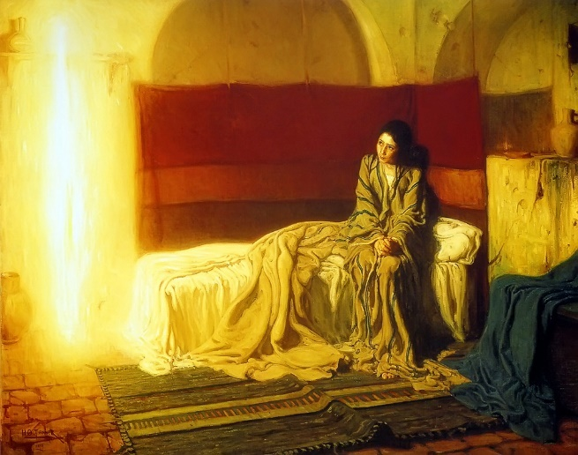
A PowerPoint of the image opposite accompanies this reflection, which may be projected for the children to look at. The painting from 1898 is called ‘The Annunciation’ by Henry Ossawa Tanner. He was one of the first African American artists to be internationally recognised, although he ended up living in Paris because of the racism he experienced in America. His father was a church leader and his mother had been a slave, who escaped to the North using the underground railroad. He was a realist painter and collected the pots and the red wall hanging on a visit to Jerusalem. He modelled Mary on the Middle Eastern peasants he had seen there and painted the Angel Gabriel as a shaft of light because he didn’t want to use a human model.

Explain to the children:

In this fourth week of Advent, we have been thinking about Mary and her reactions when the Angel Gabriel told her she would give birth to God’s son. The picture on the board is an artist’s impression of how he imagined the scene in the story.

What do you notice about the painting? What else can you see? Can you spot something that you think nobody else in the class will have noticed?

You might draw out of them that the angel’s body makes the shape of a cross against the shelf on the wall behind him, or that the blue cloth on the right hand side was traditionally used as the colour for Mary as a symbol of purity. They might notice the small oil lamp in the alcove on the right, which seems very dim compared with the brightness of the angel, or Mary’s bare feet which show her simplicity. It has been suggested that the rug is rucked up because Mary was startled and jumped back onto the bed. Perhaps the bedclothes are rumpled because she was disturbed in the middle of the night?

Why do you think the angel is shown as a beam of light? What are the good things about light? (Life can’t exist without it, it helps you see, it brings warmth, it chases the darkness away….) Why do you think Jesus said that he was the light of the world? Did he mean a literal light, or something else?

Guided Reflection
This reflection is taken from the book “Stilling” by Michael Beesley. It takes up the idea of the beam of light that Tanner used for the angel. Explain to the children that they’re going to be still for a few minutes and use their imagination. If they’re not used to this kind of exercise, then encourage them to relax and close their eyes without feeling self-conscious. It’s normal to giggle a bit when we feel awkward, but ask them to sit quietly and to respect other people in the class. It helps if you can practise the script first and use a slow, calm voice as you read the words. There is a helpful guide to using stilling with children here, by Lat Blaylock who wrote some of the Understanding Christianity resources.

After the exercise, give the children some time to come back to the reality of the classroom. Don’t ask them to share what they’ve experienced, but they might like to comment generally on how it made them feel or how easy (or not) they found it to be still and focus. This needs to be done in an affirming, accepting way.

“Light in my Breathing.”

Take up a well-balanced position….
With a straight back….
And both feet on the floor….
So that you will feel comfortable and able to be still for a few minutes without wanting to move….
Let your eyes close….

Notice the gentle rhythm of your breathing….
This is the rhythm of your life….
Value each breath….
Notice how it comes into you….
And how it goes away….
Be aware that no two breaths are ever exactly the same….
In length….
Or depth….

Suggest to yourself that every time you breathe out, any worries, stresses or tensions you may have are just flowing out of you….
Feel them melt away each time you breathe out….
As you become more relaxed….. (Pause)

Now turn your attention to each breath coming in….
Feel how it brings you new life….
Energy….
Comfort….
Warmth….
Strength….
Whatever you need.
Notice how these good things grow inside you with every incoming breath…. (Pause)

Now imagine that each time you breathe in, a warm light begins to glow inside you….

As this light gets brighter, it shows you some of the good things about your body and what it does for you….
What good things is the light showing you about your body and what it does?.... (Pause)

The light is now showing you some of the good things about your mind and the amazingly clever things it can do….
What is the light showing you about the good things of your mind?..... (Pause)

The light is also showing you the good things of your spirit, and the qualities which shine out to other people through your personality….
What is the light showing you about the good qualities of your personality?.... (Pause)

Take time to value and to enjoy all these good things within you, in the light of each breath…. (Pause)

Now slowly and gently bring yourself out of the exercise, when you are ready, and open your eyes again.

Closing prayer

In this picture, the angel came to Mary like a beam of light and told her that God was pleased with her and had good plans for her.

In the guided reflection just now, we thought about all the good things in our bodies, our minds and our spirits. Things that make us smile and bring us joy.

I’d like you to close your eyes now. I’m going to finish with our prayer for the week and if you’d like to make it your prayer, you can say amen at the end.

Dear God,
Thank you that we can find joy and laughter in ordinary, everyday things.
Thank you that Mary trusted you and was glad that you had chosen her.
We pray for people who don’t feel joyful at the moment and ask that you will help them find smiles in unexpected places.
Amen.

