Advent Guided Reflection - Week 3
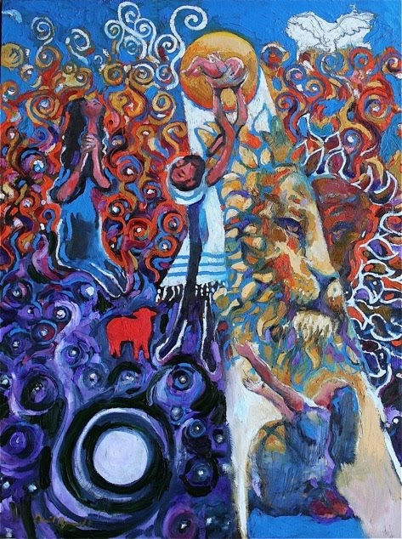
His Name Is John

Teacher Notes

A PowerPoint of the image opposite accompanies this reflection,
which may be projected for the children to look at.
The painting is called ‘His Name is John’ by Daniel Bonnell and
illustrates the story of John the Baptist being named by his
parents, Elizabeth and Zechariah.

Explain to the children:

In this third week of Advent, we have been thinking about
John the Baptist and how he went out into the countryside to
tell people that Jesus was coming to lead them in the way of
peace and love. We have also heard about something that
happened when Jesus’ mother, Mary, visited John the Baptist’s mother Elizabeth. Today we are going to think about something that happened how John was given his name. The picture on our board is an artist’s impression of how he imagined this story, you may find it helpful to look at the picture carefully while I tell you about it.

The Story (from the Gospel of Luke, Chapter 1)

You may remember from our last reflection that Elizabeth and Zechariah had been especially chosen because they loved God. Zechariah was actually a priest and when the Angel Gabriel appeared to him, he had been praying in the temple that he and Elizabeth could have a baby – even though he knew that this was not very likely because they were both quite old. But when the Angel Gabriel appeared, he told Zechariah that because he and Elizabeth loved God so much, they had been especially chosen. They were indeed going to have a son and they must name him John (which means God is Gracious). Gabriel told them that John would be filled with the Holy Spirit and that when he grew up, he would go out and get people ready to hear about Jesus.

Well Zechariah found it very hard to believe all of this and for a moment he doubted what the angel had said. So Gabriel said, ‘So that everyone will know that this is God’s will, the next time you will be able to speak is when you give John his name.’ And that is exactly what happened. After Elizabeth had given birth to the baby, all of her family and friends gathered around so that the baby could be given his name.

Everyone said that the baby should be called Zechariah after his father and they looked over at Zechariah expecting him to be happy, even though he couldn’t speak. But Zechariah shook his head and picked up a writing tablet. On the tablet, he wrote, ‘His name is John.’ From that moment, Zechariah was able to speak again. Everyone rejoiced and said, ‘Surely this must be God’s will.’

Reflection

Let’s now look at the picture together….

What words would you use to describe the picture? Is it a sad picture or a joyful picture?

Who do you think the different people in the picture are?
(The male and female figures are presumably Zechariah and Elizabeth holding up John. The female figure at the front is presumably Mary?)

Do you notice that the Mary has the shadow of a cross on her tummy – why do you think this is? (Perhaps it prefigures what is to become of her baby.)

Why do you think there is a shining pathway down between the baby John and Mary’s tummy?
(Because God said that John the Baptist would go out and prepare the way for people to hear Jesus’ message of peace and love.)

What do you think the white bird-like figure is on the top right-hand side?
(The Holy Spirit)

Why do you think there is a red lamb?
(Because Jesus would be the ‘lamb of God’ who would end up having to die so that people could be forgiven. In the gospel story, John says ‘Behold the Lamb of God who takes away the sins of the world!’ when he is baptising people in the River Jordan and he sees Jesus coming.)

Why do you think there is a lion’s face?
(The head of a lion is a traditional symbol used in art to represent courage, justice, power, wisdom and dignity.)

Why do you think there are dark swirling patterns at the bottom leading to colourful swirling patterns at the top?
(Perhaps because Jesus has come to lead people from darkness to light.)

Closing prayer

I’d like you to close your eyes for our final reflection now.

Just like God had a purpose for John the Baptist, God has a plan for each one of us. God wants us to take his values out into the world so that we can play our part in making it more like He wants it to be. Perhaps you might like to think of one way in which you could do this over the coming week.

I’m going to finish with our prayer for the week and if you’d like to make it your prayer, you can say amen at the end.

Dear God
Help me to remember that Jesus came to earth to spread
A message of love for those who are most in need.
Give me the courage to show kindness to others
So that love may grow in my heart and in the world.
Amen

