Advent Guided Reflection - Week 2
My peace, I leave with you

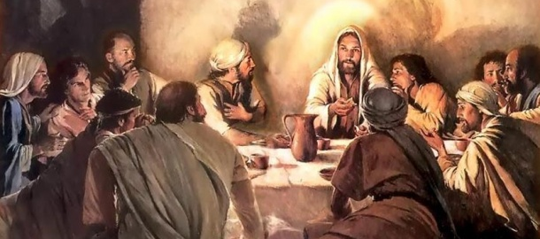
Teacher Notes

A PowerPoint of the image opposite accompanies this reflection, which may be projected for the children to look at. It is inspired by the words, ‘My peace, I leave with you,’ spoken by Jesus to his disciples a short time before he was betrayed, arrested and taken away by Roman soldiers.

Explain to the children:

It might seem strange thinking about the events we commemorate at Eastertime during Advent. However, sometimes looking back from the end of something helps us to understand the purpose of the start, and in this case understanding the kind of person the prophet Isaiah said Jesus would be. He foretold the coming of the Messiah describing him as the ‘Prince of Peace’. Also, one of the hallmarks of the Christmas story is when the angels appear to the shepherds and proclaim, “Peace on earth!”
However, at the time of Jesus, people were hoping for a Messiah that would free them from Roman occupation – perhaps someone of physical strength and military authority that would free God’s people. But God had other ideas. Instead, he sent Jesus to be the ‘Prince of Peace’. Jesus spent much of his teaching talking to people about the importance of loving God and loving one another – in fact, the second one was given as a new commandment by Jesus. When Jesus knew that his life on Earth was coming to an end, he explained to his disciples that his peace (a deep inner peace) would be given to them. The Holy Spirit was to come, a part of God that can exist in everyone, enabling us all to experience God’s peace. Not only could Jesus bring peace in his physical time on Earth but he enabled God’s peace to be something we can all experience for evermore.

The Prophecy (from the Book of Isaiah, Chapter 9 vs 6-7):

For a child has been born for us, a son given to us; authority rests upon his shoulders; and he is named Wonderful Counsellor, Mighty God, Everlasting Father, Prince of Peace.
Jesus comforts his disciples (John’s Gospel, Chapter 14, vs 26-27):

….the Holy Spirit, whom the Father will send in my name, will teach you all things and will remind you of everything I have said to you. Peace I leave with you; my peace I give you. I do not give to you as the world gives. Do not let your hearts be troubled and do not be afraid.
(NB You could also play the piece, ‘A Gaelic Blessing’ by John Rutter, which is inspired by the words Jesus spoke to his disciples : https://www.youtube.com/watch?v=8qvMFlL62XA)

Reflection

Let’s now look at the picture together….

How do you think the characters in this picture are feeling?
Does it look like everyone fully understands what Jesus is saying to them?
Sometimes, do we not always fully appreciate what is being said to us – that understanding comes later. Can you think of any examples where this has been true for you?
Does this picture convey a feeling of peace?
Could Jesus have left the disciples with a different set of commands and instructions?

How can we demonstrate a peaceful attitude towards each other?
What do you think having a feeling of peace inside of us is like? How would we know?

Closing prayer

The prayer for this reflection is inspired by the prayer of St Francis of Assisi.

I’d like you to close your eyes now and if you’d like to make it your prayer, you can say amen at the end.

Lord, make me an instrument of your peace. Where there is hatred, let me sow love; Where there is injury, pardon; Where there is doubt, faith; Where there is despair, hope; Where there is darkness, light; and Where there is sadness, joy. Divine Master; Grant that I may not so much seek to be consoled as to console; to be understood as to understand; to be loved as to love; For it is in giving that we receive; it is in pardoning that we are pardoned; and it is in dying that we are born to eternal life. Amen.

