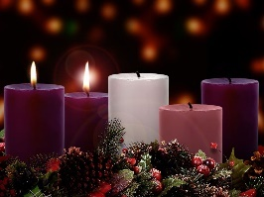
Advent Guided Reflection - Week 2
The Prince of Peace

Teacher Notes

A PowerPoint of the images opposite and below accompany this reflection, which may be projected for the children to look at. The painting opposite is called ‘The Prince of Peace’ by Mark Lawrence and below ‘Hallelujah’ by Mike Moyers.
The Old Testament prophet Isaiah describes the coming Messiah (Jesus) as the ‘Prince of Peace’.

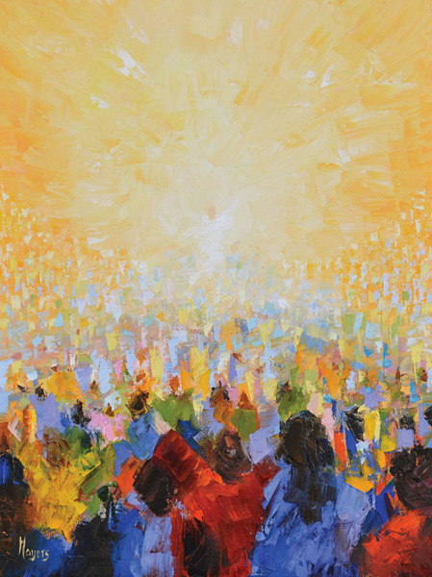
Explain to the children:

In this second week of Advent, we have been thinking about the Old Testament prophets and how they went out, over many hundreds of years, telling people to turn from their sinful ways, to love God and honour his commands. In particular, the prophet Isaiah, remembered at Christmas as he predicts the coming of the Messiah - Jesus. This week’s value of peace also links to a name that Isaiah uses to describe the Messiah – ‘The Prince of Peace’. One picture on our board is an artist’s impression of how he imagines the Prince of Peace to be in terms of colour, texture and pattern. The other, called ‘Hallelujah’ considers how the Prince of Peace might appear to us in person. Choose one of the pictures to look at whilst listening carefully as one of us reads from the book of Isaiah – listen out for the different names Isaiah uses to describe the Messiah.

The Prophecy (from the Book of Isaiah, Chapter 9 vs 6-7):

For a child has been born for us,
a son given to us;
authority rests upon his shoulders;
and he is named
Wonderful Counsellor, Mighty God,
Everlasting Father, Prince of Peace.
⁷ His authority shall grow continually,
and there shall be endless peace
for the throne of David and his kingdom.
He will establish and uphold it
with justice and with righteousness
from this time onward and forevermore.

Reflection

(NB You could also play the movement, ‘For Unto us a Child is Born’ from Scene 3 of Handel’s ‘Messiah’, that uses the words from these verses: https://www.youtube.com/watch?v=MS3vpAWW2Zc)

Let’s now look at the pictures together….

Prince of Peace | Hallelujah
Questions:
Do you like either of the paintings? Which one do you prefer – why?
How do you think they convey the idea of Jesus being the Prince of Peace?
Potential discussion points:
- Peaceful colours have been used  - The colours work in harmony with each other (they are close to each other on the colour wheel), just like us if we are at peace with each other  - Purple is a colour often associated with royalty - Jesus was prophesied to be the Prince of Peace  - There are no lines creating separate sections or barriers. If we live peacefully with each other, there should no need for barriers or segregation  - The design appears to sweep from the top right to the bottom left (or vice versa). This shape resembles the wing of a bird (perhaps a dove to symbolise peace) or that of an angel. | - Locate Jesus – the bright white/yellow radiating peace and love  - Jesus is depicted as lifted high above everyone else – this reminds us of his perfection, holiness and authority  - The crowd are painted in many different colours, reminding us that Jesus came for all – all of us are made in God’s image and valued by him  - White light radiates outward from Jesus, reminding us that peace and love can radiate outward from us too – it spreads and consumes darkness

Closing prayer

I’d like you to close your eyes now. I’m going to finish with our prayer for the week and if you’d like to make it your prayer, you can say amen at the end.

Dear God
Thank you that you are the God that gives peace. Help us to trust fully in you and rest in the peace that you offer. Help us to be at peace with one another during this time of Advent and always.
Amen

