Advent Guided Reflection - Week 1
Hope

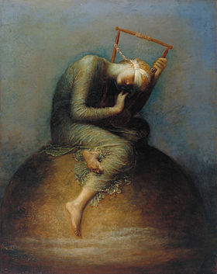
Teacher Notes

A PowerPoint of the image opposite accompanies this reflection, which may be projected for the children to look at.

Explain to the children:

This week we have looked at hope as our focus for week 1 of Advent, the time when Christians across the world prepare for the birth of Jesus as a gift from God.

Talk to the children about how Christmas is a time that should fill our hearts with hope in God, no matter what we are going through or have gone through. It's a time that reminds us of the coming of Jesus, who came to rescue us at just the right time. His life, from birth to death to his resurrection, gives us hope.

‘Nevertheless, that time of darkness and despair will not go on forever. For a child is born to us, a son is given to us. The government will rest on his shoulders. And he will be called: Wonderful Counselor, Mighty God, Everlasting Father, Prince of Peace.’
Isaiah 9:1, 6-7

Explore with the children about why the world has found it difficult to be hopeful recently. It is important to acknowledge that having hope is not always easy.

Reflection

Let’s now look at the picture together….

- How do you think the character in this picture is feeling?
Ask the children to offer some words for you to write in a list – sad, lonely, hopeless, alone, despair.
‘Hope’ depicts a blindfolded woman seated, hunched on a globe, bending her neck to listen closely to the lyre, which is completely frayed but for one string.

- How has the artist chosen colour to represent the emotions?

- In light of all this. why do you think the picture is called Hope?

Tell the children that there is another way of looking at this painting. In fact George Frederic Watts’s Hope is Barack Obama’s favourite painting. Explain to the children that Obama (pictured on the second slide on the Powerpoint) was America’s first black president. When he was young, he heard a vicar talking about the hope shown by the figure in the painting. Obama found the painting so inspirational that he talked about it in many speeches.

- Let’s try and see what inspired him. Look at the picture again. What is the character doing despite having a blindfold and only one string left on her instrument?

The figures is alone, blindfolded and isolated, but still clasping onto the beauty of faint music. She dares to have hope in the last remaining string of her instrument.

Can the children see that, despite the picture being dark, her face is lighter to show that she is listening to the music, showing that she has hope. The painting’s title reflects the idea that in a world of negatives we should try to remain positive.

Ask the children if they feel differently about the painting if they see the hope and not the despair.

Closing prayer

Dear God, on the first Christmas you gave the world a gift of hope wrapped in cloths and lying in a manger. Thank You that I can always hope in You. In every situation and every problem that I am going through. I trust that you will make things better in the world and I will stay hopeful, knowing that you are there for me today and always.
Amen.

