Advent Guided Reflection – Week 1
Candles of Hope

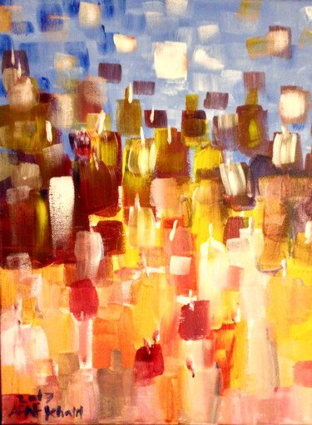
Teacher Notes

A PowerPoint of the image opposite accompanies this reflection, which may be projected for the children to look at. The painting opposite is called ‘Candles of Hope’ by Afaf Artmajeur.

Explain to the children:

In this first week of Advent, we have been thinking about how God made a promise to send his Son to Earth to give people hope of a better life. Our first candle is called the Candle of Hope.
As a light shines in the dark and the darkness can not extinguish the light, so the candle of Hope represents the hope we have in Jesus. The Bible tells us that:
‘For God so loved the world, that he gave his only Son’ John 3:16
Especially during Advent, we look forward to Jesus coming to Earth.
In churches on this first Sunday of advent the first candle will flicker into life on our advent wreaths; a candle of hope. The flame of the candle is very fragile.

Reflection
Now let’s look at the picture:

- Look at the picture carefully and tell me what you can see.
When the children answer ‘candles’, ask them how they know they are looking at candles. Ask the children if they can really see them or can they just see blocks of colour. Talk about how the artist has managed to make us think of candles, even though there are actually very few candles in the painting.

Advent forces to think about the kind of world that God wants us to live in. Advent forces us to imagine a world beyond what we can actually see - just like the candles in this painting.
- How do you think the artist manages to make us think that there are lots of candles in her picture?

- Does the picture make you feel cold or warm? Why is this?
Colours used. The space away from the candles at the top of the painting is blue and white (colder colours). There is a hint of flame on some candles.
- Is it hotter or colder at the bottom of the painting? Why?

- If the artist had painted Jesus on her picture, where would he be standing? Why?

- The artist wo created this painting said that she sometimes finds it difficult to talk about or wrote what she means, so she paints her feelings instead. Look at the painting, hat do you think she feels about hope? Do you think she is a hopeful person? Why?

Closing prayer

I’m going to finish with our prayer for the week. You may like to look at the painting while I read the prayer. If you’d like to make it your prayer, you can say amen at the end.

Dear God, on the first Christmas you gave the world a gift of hope wrapped in cloths and lying in a manger. Thank You that I can always hope in You. In every situation and every problem that I am going through. I trust that you will make things better in the world and I will stay hopeful, knowing that you are there for me today and always.
Amen.

